Blount County Genealogical and Historical Society
Annual Picnic
May 21, 2022
Starting at 11:30 a.m.

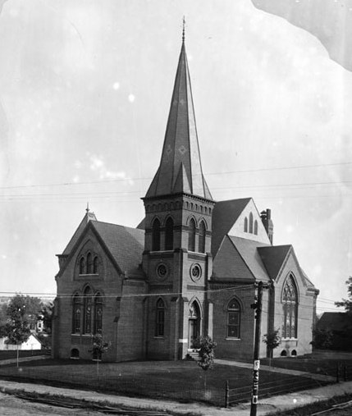
Join us for a pot luck picnic at Maryville's New Providence Presbyterian Church Pavilion followed by a history program presented by Duncan Crawford, whose family have been Church members for over 200 years.
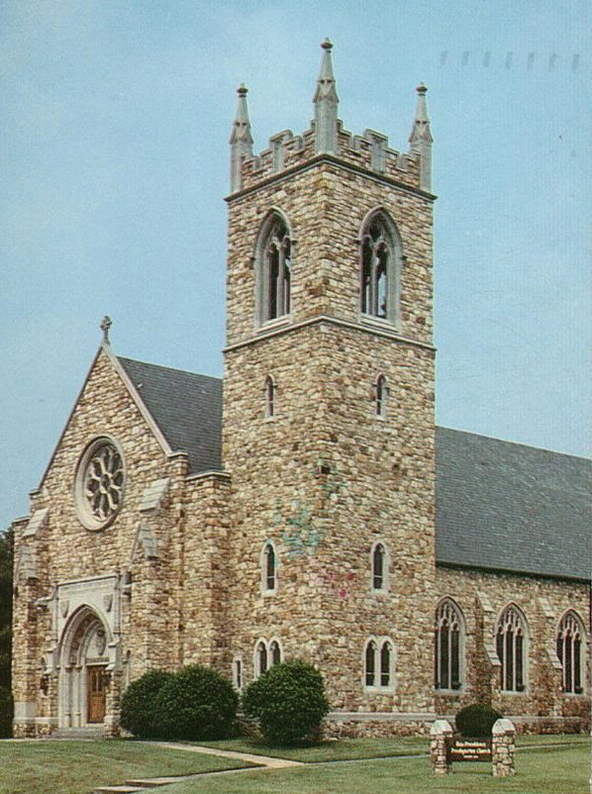
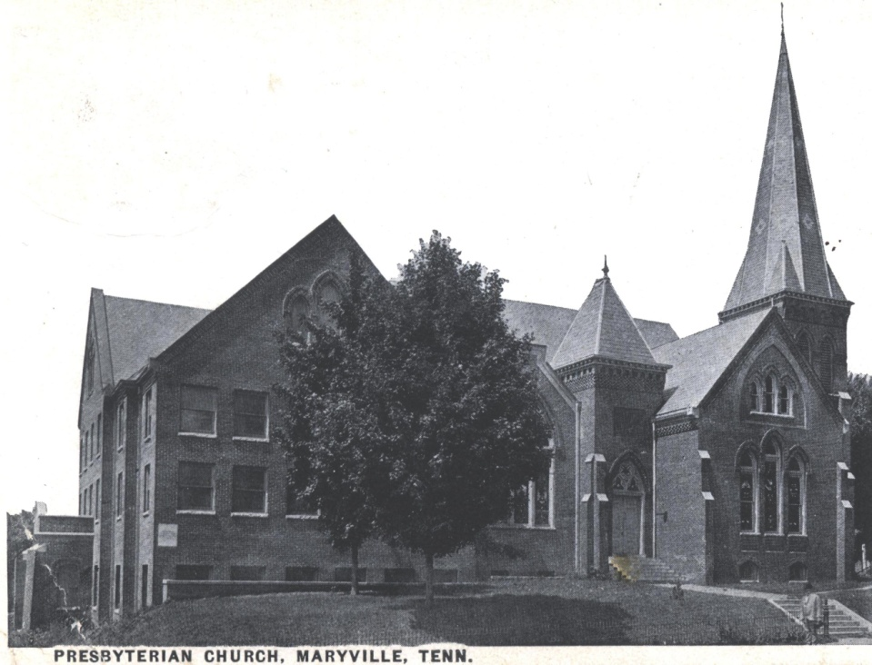
This event is FREE AND OPEN TO THE PUBLIC. Everyone should bring a drink and side dish to share.
Come
Join Us!

Sponsored By
The Blount County Genealogical and Historical Society

